Task 1
Azure subscription with 100$ credit
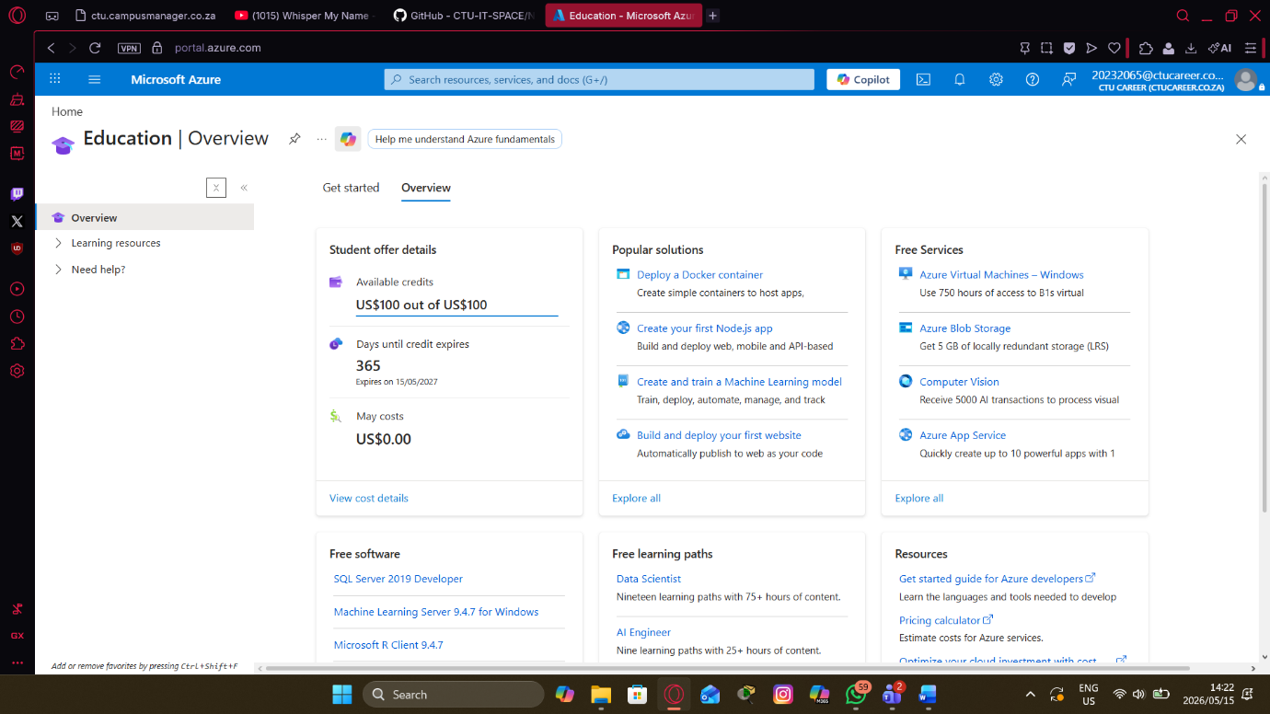

Task 2
CTU is a private tertiary education school with multiple schools across South Africa. It emphasizes practical, industry-relevant skills, blending in-person and online platforms. Its main IT needs include a robust Learning Management System, virtual labs, student portals, administrative systems, collaboration tools, and secure management of student/staff data, with strong emphasis on supporting hybrid and online learning across multiple locations. A cloud solution such as Azure is highly beneficial compared to on-premises infrastructure because it offers better scalability for fluctuating student numbers, lower upfront and maintenance costs, seamless remote/hybrid access, high availability with built-in disaster recovery, and direct alignment with CTU’s curriculum as they already deliver Microsoft Azure and related certifications. Key security and compliance requirements involve adherence to South Africa’s POPIA, strong identity/access controls, data encryption, audit logging, and alignment with standards such as ISO 27001. The expected number of cloud users includes 200–600 staff members plus several thousand students and learners (full-time, part-time, short courses, and corporate), with concurrent access varying by academic cycles and potential for significant growth as online offerings expand.

Task 3
Azure Service | Purpose / Why you need it | Week it is used
Resource Group | A logical container used to manage azure resources | 01
Virtual Network (VNet) | A virtual network in Azure | 02
Virtual Machine (VM – B1s) | IaaS that allows to create a digital instance of a computer | 03
Microsoft Entra ID | Azure’s Identity solution | 04
Network Security Group (NSG) | Controls in-outbound traffic in Azure resources | 05
Azure Storage Account | Azure’s storage location
Microsoft Defender for Cloud | Provides an effective security solution for azure | 06
Azure Monitor | Tracks and logs health and performance of azure services | 07
Azure Cost Management | Creation of bills and spending limits in azure | 08

Task 4
